**NAME: YOHENBA KSHETRIMAYUM**

**REG NO: RA1911003010904**

**WEEK: 1**

**Experiment Number:1**

**Date:4/5/2021**

**Aim: To solve allotted week 1(SET3) python exercises**

1. A positive integer is called a perfect number if it is equal to the sum of all of its positive divisors,

excluding itself. For example, 6 is the first perfect number, because The next is There are four perfect

numbers less than 10,000. Write a program to find these four numbers.

def perfect(n):

sum = 1

i = 2

while i * i <= n:

if n % i == 0:

sum = sum + i + n/i

i += 1

if sum == n and n != 1:

return True

else:

return False

n = 1

for n in range (7,10000):

if perfect (n):

print(n)

**OUTPUT:-**

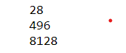

2. (Twin primes) Twin primes are a pair of prime numbers that differ by 2. For example, 3 and 5, 5

and 7, and 11 and 13 are twin primes. Write a program to find all twin primes less than 1,000.

Display the output as follows:

def is_prime(n):

for i in range(2, n):

if n % i == 0:

return False

return True

def twins(start,end):

for i in range(start, end):

j = i + 2

if(is_prime(i) and is_prime(j)):

print("({:d},{:d})".format(i, j))

twins(2, 1000)

**OUTPUT:-**

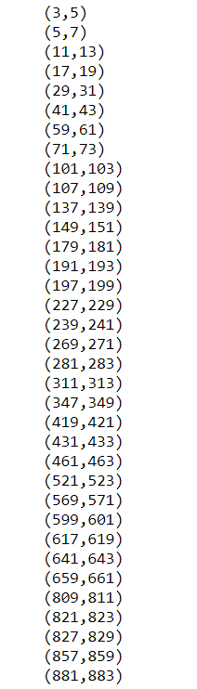

3.A prime number is called a Mersenne prime if it can be written in the form 2^n-1 for some positive

integer p. Write a program that finds all Mersenne primes with and displays the output as follows:

def number(n, prime):

for i in range(0, n + 1):

prime[i] = True

p = 2

while (p * p <= n):

if (prime[p] == True):

for i in range(p * 2, n + 1, p):

prime[i] = False

p += 1

def mersennePrimes(n):

prime = [0] * (n + 1)

number(n, prime)

k = 2

while (((1 << k) - 1) <= n):

num = (1 << k) - 1

if (prime[num]):

print(num, end=" ")

k += 1

n = 10000

print("Mersenne prime numbers smaller",

"than or equal to ", n)

mersennePrimes(n)

**OUTPUT:-**

C:\Users\Yohenba Kshetrimayum\Desktop\Screenshot 2021-02-05 113055.png

4. (Financial application: compute future tuition) Suppose that the tuition for a university is $10,000

this year and increases 5% every year. Write a program that computes the tuition in ten years and the

total cost of four years‟ worth of tuition starting ten years from now.

price = 10000

total = 0

for i in range(1,14):

price += price * 0.05

if i == 10:

print("price in 10 yrs :")

print(price)

if i > 10 :

total += price

print("price after 4 years after 10years: ")

print(total)

**OUTPUT:-**

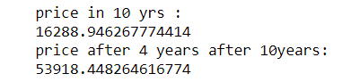

5. (Find the two highest scores) Write a program that prompts the user to enter the number of students

and each student‟s score, and displays the highest and secondhighest scores.

lst = []

n = int(input("Enter number of marks : "))

for i in range(0, n):

ele = int(input())

lst.append(ele)

for i in range(0, n):

for j in range(0, n-i-1):

if lst[j] < lst[j+1] :

lst[j],lst[j+1] = lst[j+1], lst[j]

print("highest 2 numbers")

print(lst[0],lst[1])

**OUTPUT:-**

